e.f. vz; 13/2022/m M R ep / ehs; 03.12.2022

mDg;Geh;

kUj;Jt mYtyh;

Nkyuhkejp muR Muk;g Rfhjhu epiyak;

Nkyuhkejp

Gukf;Fb (HUD)

fKjp

ngWeh;

tl;lhu kUj;Jt mYtyh;

muR Muk;g Rfhjhu epiyak;

NgiuA+h;

Iah

nghUs; : nghJ Rfhjhuk; fKjp tl;lhuk; Muk;g Rfhjhuk; epiyak;

jiutop njhiyNgrp ,izg;G njhlh;ghf

ghh;it : e.f. vz; 435 MRpe 2022 tl;lhu muR Muk;g Rfhjhu epiyak;;;

ehs; 01.12.2022

ghh;itapy; cs;s fbjj;jpd; gb gukf;Fb kUj;Jt cs; khtl;lk; Nkyuhkejp

muR Muk;g Rfhjhu epiyaj;Jf;F jiutop njhiyNgrp ,izg;G ngw 20.10.2022 md;W

BSNL njhiyNgrp mYtyfj;jpy; tpiy tptuk; ngw ngw;W 03.12.2022 md;W jiutop njhiyNgrp

Gjpjhf ngwg;gl;Ls;sJ. njhiyNgrp vz; 04576-221186 vd;gjid jq;fspd; Nkyhd ghh;itf;F

njhpa gLj;JfpNwhk;.

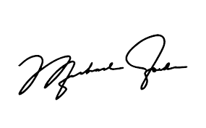

kUj;Jt mYtyh;,

muR Muk;g Rfhjhu epiyak;

+Nkyuhkejp